Universality of Human Language

Definition
# Source: AI Source: Provided by: [Data Path: Persons Table -> ID Column: 1, Name_En Column: Motasem Essam] -> From: [Chatgpt (GPT‑5 Mini)] on [10/23/2025]
The universality of human language means that:
➡️ All human languages share certain fundamental features, because they are all products of the same human brain and cognitive system.
In other words:
Despite differences in words and sounds, every language follows universal principles of structure and grammar that reflect our shared human nature.

🧠 Chomsky’s View: Universal Grammar (UG)
# Source: AI Source: Provided by: [Data Path: Persons Table -> ID Column: 1, Name_En Column: Motasem Essam] -> From: [Chatgpt (GPT‑5 Mini)] on [10/23/2025]
Chomsky argued that the ability to learn language is innate — humans are born with a built-in system called Universal Grammar (UG).
- UG = the set of structural rules and principles that all human languages have in common.
- Each individual language (English, Arabic, Japanese, etc.) is a variation on this same underlying system.

💡 Examples of Universal Features
# Source: AI Source: Provided by: [Data Path: Persons Table -> ID Column: 1, Name_En Column: Motasem Essam] -> From: [Chatgpt (GPT‑5 Mini)] on [10/23/2025]
- All languages have structure
→ Words combine into phrases, phrases into sentences.
Example: Subject–Verb–Object patterns (e.g., I eat apples).
- All languages can express negation, questions, and time.
- All children acquire language naturally
→ Regardless of the language or culture, children pass through similar stages (babbling → single words → short sentences).
- Creativity of language use
→ Speakers of any language can produce and understand new sentences they’ve never heard before.

🔍 In Short
# Source: AI Source: Provided by: [Data Path: Persons Table -> ID Column: 1, Name_En Column: Motasem Essam] -> From: [Chatgpt (GPT‑5 Mini)] on [10/23/2025]
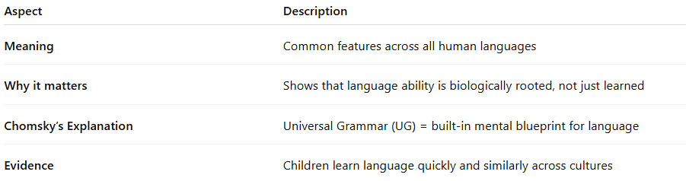
Aspect | Description
Meaning | Common features across all human languages
Why it matters | Shows that language ability is biologically rooted, not just learned
Chomsky’s Explanation | Universal Grammar (UG) = built-in mental blueprint for language
Evidence | Children learn language quickly and similarly across cultures

✨ Simple Summary
The Universality of Human Language means all humans are born with the same language potential — different languages are just different expressions of one universal human capacity for grammar and communication.

Would you like me to also explain how universality supports the Language Acquisition Model (LAD)? It connects perfectly to this concept.

